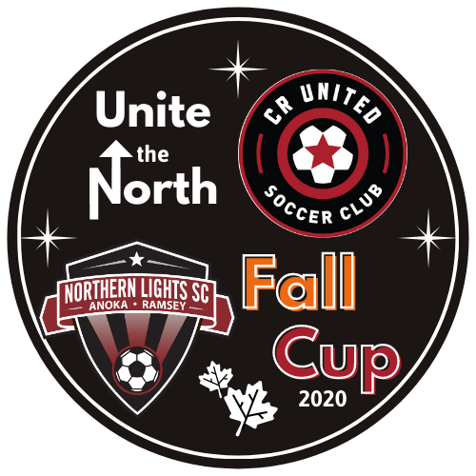
Coon Rapids Soccer Complex
Elmcrest Park
CR United Soccer Club
Northern Lights Soccer Club
Team:
Coach:
 | Player Name: | Jersey Number:
1
2
3
4
5
6
7
8
9
10
11
12
13
14
15
16
17
18
2020 Unite the North Fall Cup
Player Roster

